How to Cover a Brick Fireplace with Cultured Stone
Resurface your old brick fireplace with stone and slate.
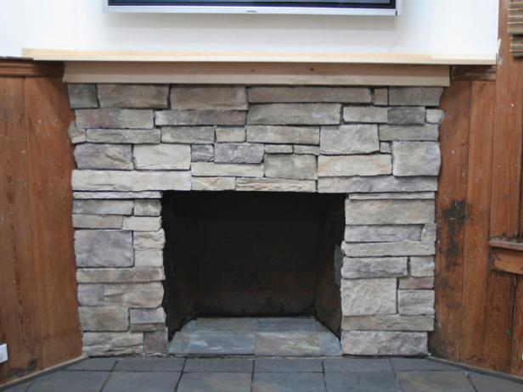
A new stone facade and slate hearth update this old, once-brick fireplace.

Tools and Materials:
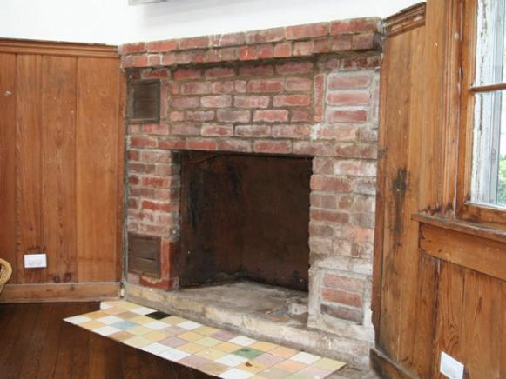
cultured stone product
mortar mix and mortar pan
2x4s for bracing
metal lath
masonry nails and hammer
plywood for hearth
lumber for the mantel
wood glue
nail gun and wood nails
slate
grout, grout float and sponge
grinder or saw with diamond-tipped blade
square and level
masonry trowel
table saw
router

Steps:
1. Remove any loose bricks. If you choose to replace a mantel and hearth as well, use a mason’s hammer to break up and remove the pieces.
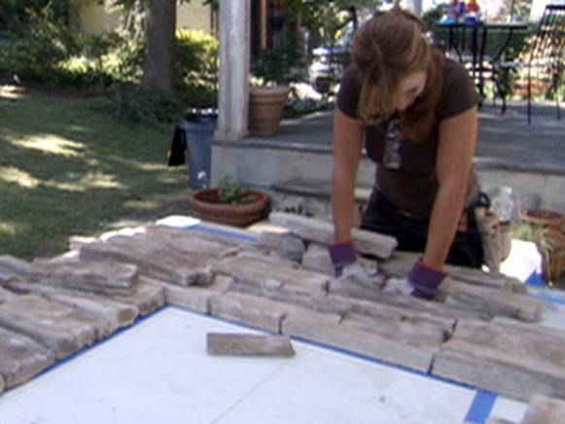
frame 1
2. Nail metal lath to brick with masonry nails and hammer, keeping clear of edges.
3. Take measurements around fireplace where new stone is desired. Create a template or outline on a wood board or table with painter's tape.
4. Lay out cultured stones in a tight pattern that fits the template. This will insure proper spacing and color distribution. Make cuts in the stone with a grinder or saw with diamond-tipped blade, then break off excess pieces along the cut line with a mason's hammer.
5. Mix one bag of mortar mix in a mortar pan with water until you have a thick soup-like or cake-batter consistency.
6. Begin installing stone at the hearth by applying mortar with a trowel to the backside of each stone. Do not mortar all sides like laying brick. Work around the firebox.
frame 1
7. When you get to the top of the fireplace, make a wood frame out of three 2x4s to support lintel stones. Nail the top piece to either support leg. (Lintel stones are the ones that span the top of the firebox.)
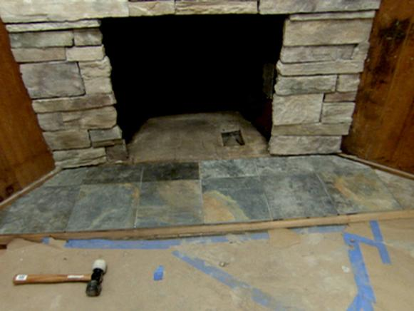
frame 1
8. Continue laying stone with mortar to the mantel. Let dry. Apply mortar with trowel to any large cracks between stones.
9. To build a new wooden hearth, measure the area desired next to the fireplace and cut a wood frame using plywood. Cut 2x4 wood pieces and attach to the underside of the plywood with wood glue and nail gun around all edges. Place the hearth against the stone and lay the slate the hearth frame with mortar.
10. When mortar dries, apply grout in spaces between stones with a grout float. Use a wet sponge to wipe away excess. When grout has dried, it’s recommended to apply a sealer between the slate pieces.
11. To build a new wooden mantel, measure the length of the fireplace and the desired width. Cut the base using chosen wood. Cut a wood piece the length of the fireplace and six inches in width. Attach it with a nail gun to the underside of the mantel, so that it will be flush with the stone wall. Add a design to the outer edges by using a router.
12. Attach mantel into the wall with nail gun.

