How to build an Outdoor Stacked Stone Fireplace

Materials Needed:
- stacked stone
- 2X4 pressure-treated lumber
- concrete foundation
- concrete cinder blocks
- backer board
- screws
- mortar
- trowel
- tape measure
- pencil
- notepad
- nail gun
- nails
- drill
- screws
- chop saw
- shovel
- chimney cap
- protective gloves
- screwdriver
- masonry anchors or bits

Step 1: Create a Design
Use tape measure to determine width, length, depth and height of fireplace. Jot dimensions down in notepad using pencil. Establish the overall look for fireplace. Consider brick for a more traditional aesthetic or man-made stacked stone for a contemporary look. Also decide if your fireplace will be wood burning or gas-lit.

Step 2: Create a Concrete Foundation
If your home doesn’t already offer a safe, flat area with a concrete slab, create one by digging a ditch, and mixing then pouring concrete.

Step 3: Lay Concrete
Referring to design, lay concrete cinder blocks, adding a layer of mortar between each block, leaving opening at top of chimney for ventilation.

Step 4: Build a Façade Frame
Referring to dimensions on notepad, cut 2X4 lumber to size with chop saw. Assemble each 2X4 with nails using nail gun or with screws using drill.
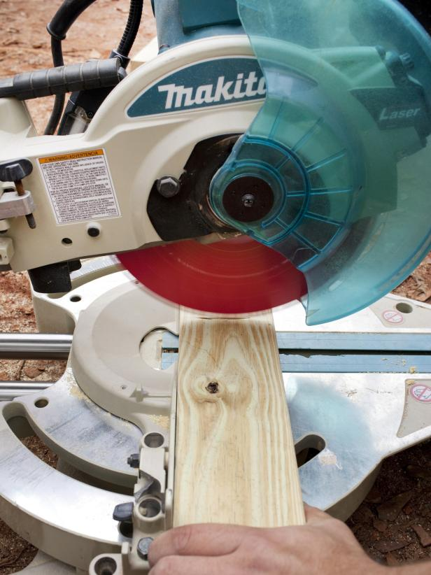
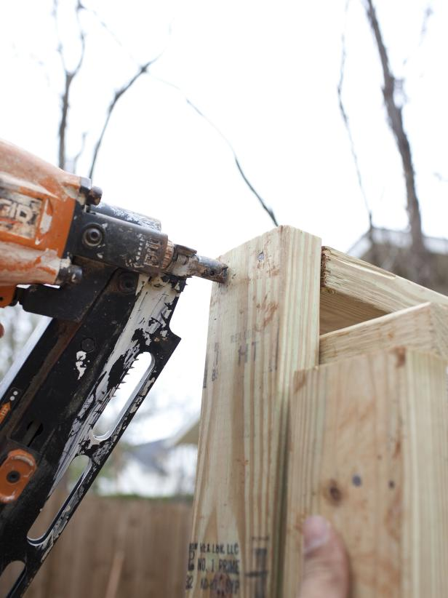
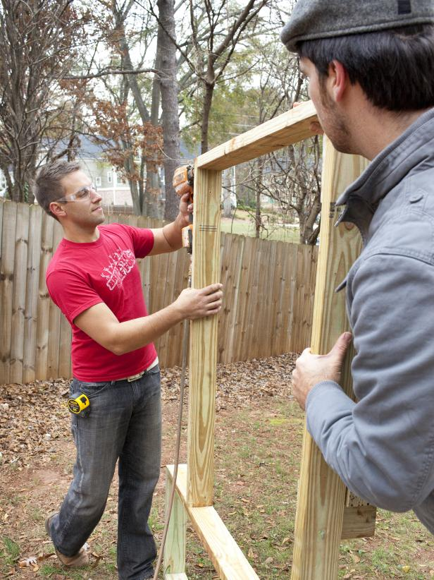
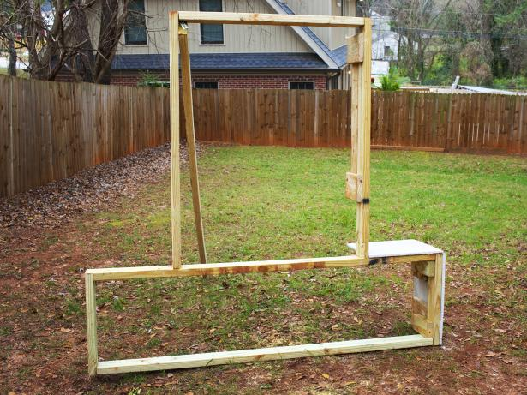

Step 5: Attach Cement Board
Cut cement board to size using chop saw. Using drill, attach cement boards to frame with concrete screws. For smaller areas of frame, use chop saw to cut cement boards to size.
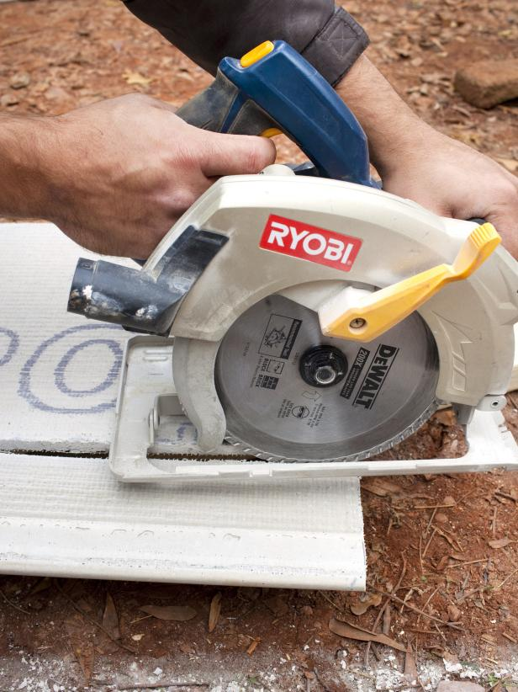
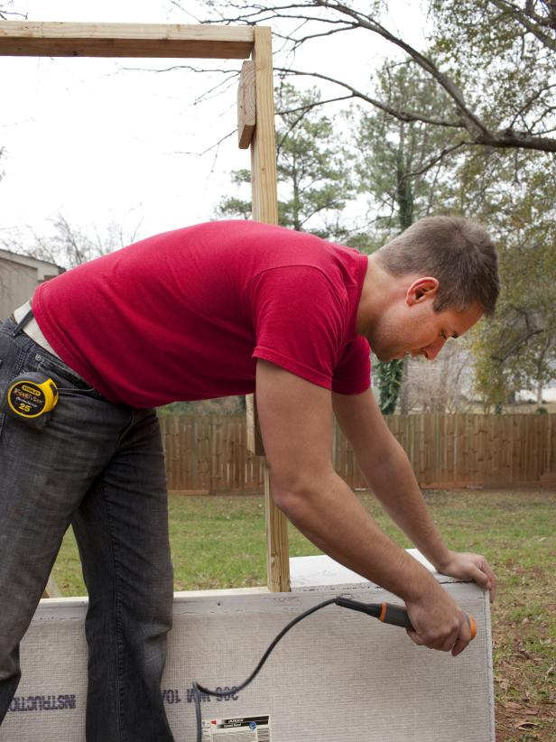
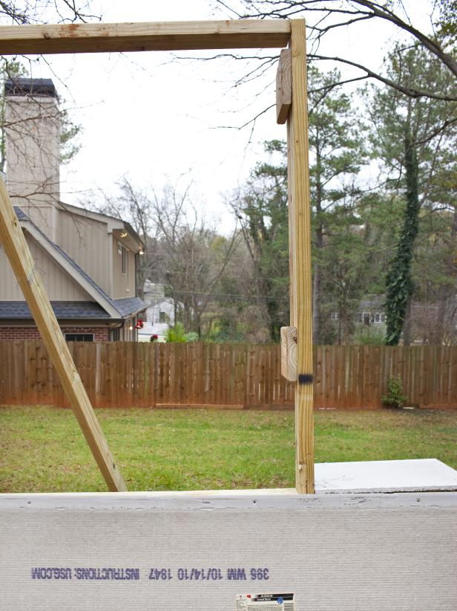

Step 6: Add Mortar
Mix mortar, referring to directions on packaging. Use trowel to scoop mortar from bucket, then add mortar to predetermined cement boards. TIP: Applying mortar in sections will keep it from drying out prior to placing stone.
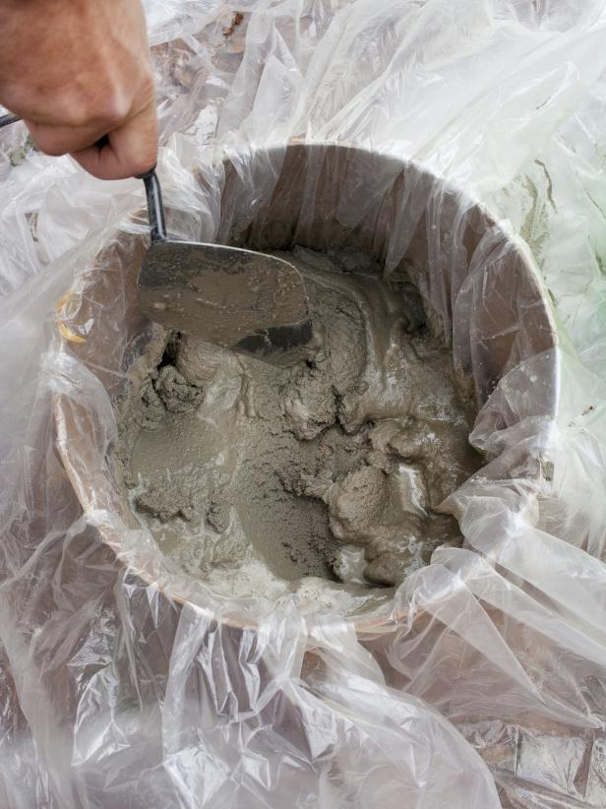
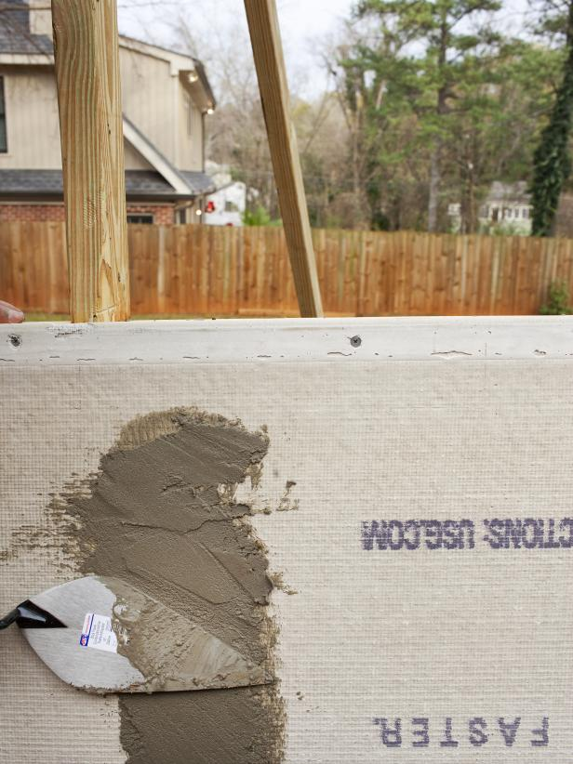

Step 7: Install Stacked Stone
Press stacked stone material into mortar, holding in place until self-supported. Continue placement of stones, ensuring no space is left between them.
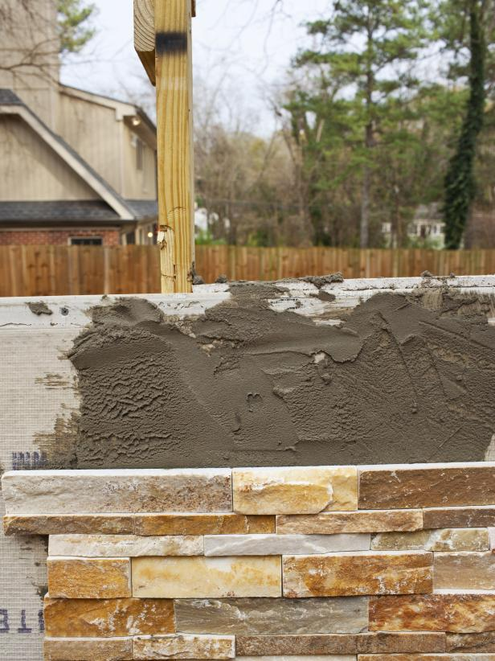

Step 8: Attach Chimney Cap
Most chimney caps are made of metal; wear protective gloves before installing. If you have a single-flue chimney cap, slip it over the flue, firmly tightening the screws on all sides of the chimney cap. Inside-mount chimney caps require a firm push directly into the flue. If your cap requires masonry anchors or bits, attach using drill.

