How to Build a Retaining Wall

TOOLS
  - shovels
  - level
  - caulking gun
  - measuring tape
  - wheelbarrow
  - rakes
  - hand tamper
  - rubber mallet

MATERIALS
  - gravel
  - self-stacking concrete blocks
  - drainage pipe
  - concrete adhesive
  - drainage sleeve
  - capstone blocks

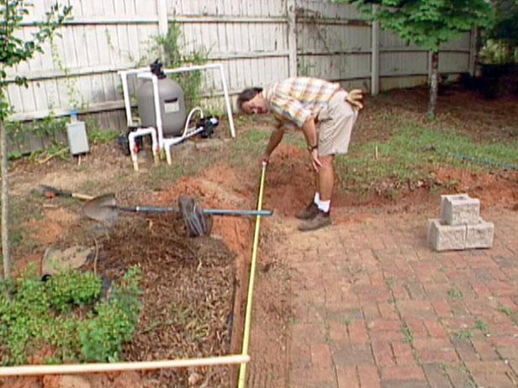

Mark the Placement of the Retaining Wall
Using a shovel, mark the ground where the retaining wall will be built. Drive long wooden stakes into the ground at each end. If the distance is greater than 8’, drive additional stakes so that the gaps do not exceed 8’. Tie a string to a stake at the wall’s desired height and stretch across to opposite stake or stakes. Use a string level to ensure that all the heights remain level and constant.

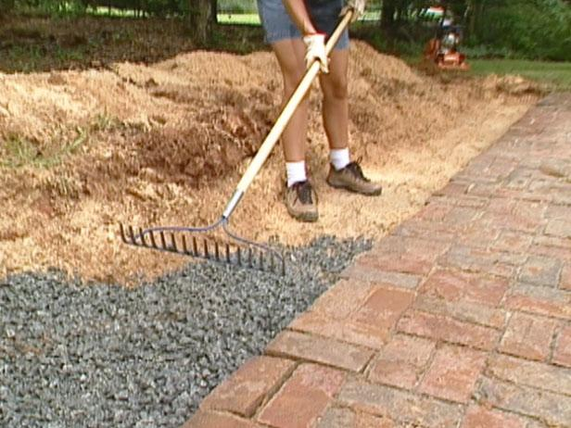

Prepare the Base
Excavate the entire area to a depth of 8”. Spread approximately 4” of gravel evenly in the trench and rake the gravel smooth. Use a hand or power tamper to compact and level the area. Check for level and add or remove gravel as necessary until the appropriate height is reached.

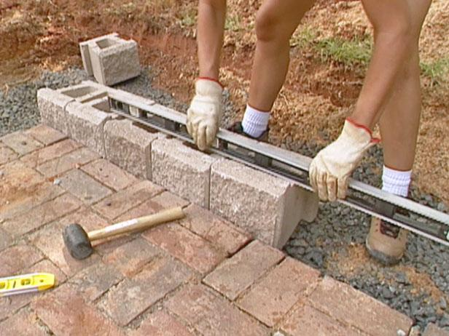

Lay the First Course
Staring at one end, place the first course of concrete blocks top side up on the crushed rock with the front lip facing up and towards the front of the wall. Check the level and alignment of all blocks as you go along, adjusting them with a rubber mallet. Fill the concrete cores with crushed gravel.

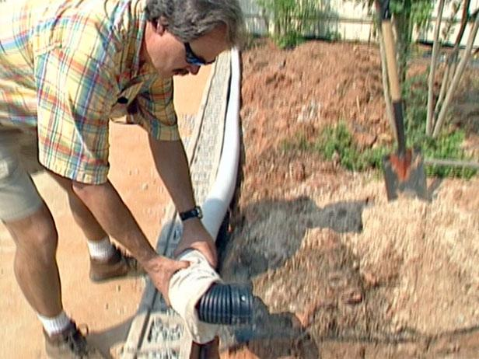

Install the Drainage Pipe
Install corrugated drainage pipe behind the first course of blocks and run the pipe to where the water can exit the area. Slip a drain sleeve over the drainage pipe to screen out sediment and prevent the pipe from clogging.

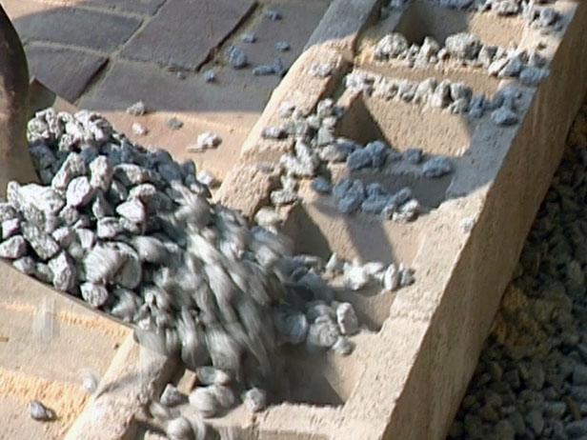

Lay the Remaining Courses
Sweep away all debris from the top of the first course of block with a broom. Stack the second course of blocks on top of the first course making sure they remain level. Fill the concrete cores with crushed gravel. Backfill with gravel behind the wall to cover the drainage pipe. Top with soil. Continue with following courses and soil until desired height is reached.

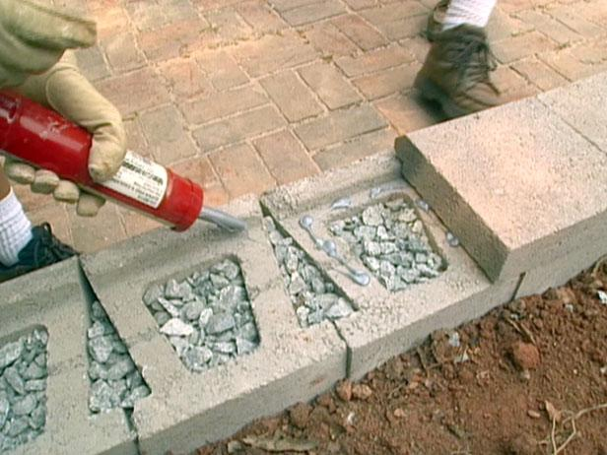

Lay the Capstones
Top the final course with capstone blocks, securing them in place using concrete adhesive and a caulking gun. Firmly press on each block. Allow the concrete adhesive to dry according to the manufacturer's directions.

